Table of Contents

Other Metrics for Ranking 2

User Behavior Metric 2

Number of clicks 2

Other click through features 2

Browsing feature 2

Query-text features 2

Probabilistic Information Retrieval 2

Ranking of documents 3

Okapi BM25 4

Document length normalization 4

# Other Metrics for Ranking

Other metrics that can be taken into account for ranking:

* Document age, type
* Query: type, temporal “orientation” (does the user want past, present, or future event, think of the weather example)
* Sponsors: The top returned results are visited more.
* User behavior:

## User Behavior Metric

* Use accumulate data about the user
* Data can be inaccurate, and interpretation could be non-trivial.
* Not all queries have previous user behavior

### Number of clicks

* Order based on number of clicks for each search results of a query.
* According to eye-tracking studies, most people look at the first 1, or 2 results only.
* Which means there is a bias towards the first 1 or 2 results. Thus using **number of clicks is biased.**

### Other click through features

* Click probability
* Click deviation
* Click on next result? Previous result? Above? Below.

### Browsing feature

* Average time spend on a page, on domain, on URL prefix
* Browse path features

### Query-text features

* Query overlap with title, snippet, URL, domain, next query.
* Query length.

# Probabilistic Information Retrieval

* Uncertainty 1: Believes that user needs are uncertain, and these needs are represented using queries making the queries uncertain.
* Uncertainty 2: How can you know for certain if the document is relevant for the user?

## Ranking of documents

* Rank based on probability of document being relevant to the query.
* Probability: What is the probability being relevant given the query.

A in this case is relevance.



Ratio of probability of a document being relevant to probability of a document not being relevant.

X: represent a document in the collection.

R: represent relevance of a document w.r.t given a query.

R = 1 means relevant and R = 0 not relevant.



* We need to be able to find: p(x | R = 1)
* Assumes that relevance of each document is independent of the relevance of other documents. This is not entirely true because two docs can belong to the same website.
* Assumes terms occur independently in text. Such that their contributions to relevance are treated as independent events. Words do not appear randomly in text.

## Okapi BM25

* Bag of words retrieval approach.
* Allows to find the probabilities in the Baye’s equations
* Kind of a version of tf.idf involving probabilities.
* Bag of words approach
* Be sensitive to different probabilities such as term frequency and document length
* Combined to find the relevance probability.
* Order the documents by decreasing probability.

### Document length normalization



* b = 0, used by tf.idf
* give a more balanced rating upon the number of length normalized times a term appears in them
* Cut out the noise elements from a document that are not likely to reflect upon its actual content.

What is document normalization?

What is term frequency scaling?



* tf is a probability
* tf is normalized.

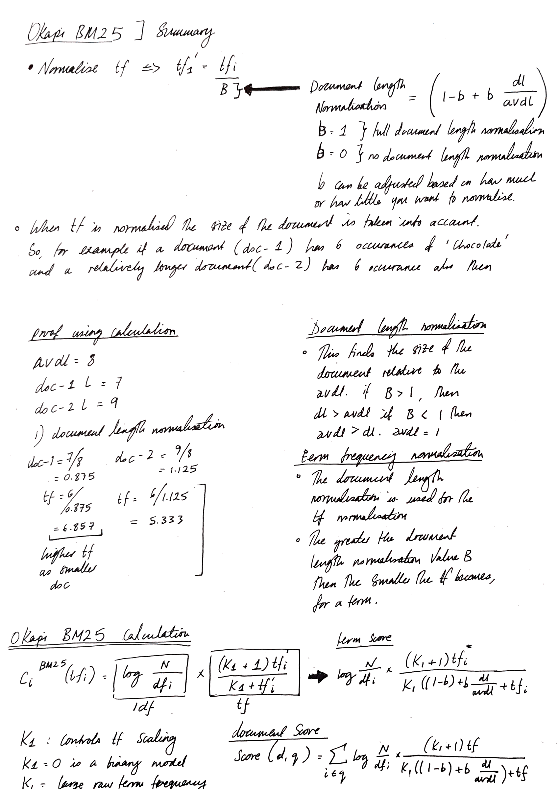

Okapi BM25F

* Classes tf in different parts of the document differently.
* Zones: Titles, author, abstract, body, anchors,…
* Calculate a weighted variant of the tf.
* A term from a query found in a title of a document may be worth more than the word appearing in the body of a document.
* Takes into account that a document has different zones.
* So, can calculate tf, dl and avdl for particular zones rather than for the whole document.





* Note: All this makes indexing slow.
* Good for some domains. More structures data.

# Improving Retrieval

* Can use global methods and local methods.
* Global methods:
  + - 1. Query expansion: **Thesauri** and **Automatic thesaurus generation.**
* Local methods:

1. **Relevance feedback** and **pseudo relevance feedback.**

## Relevance Feedback

* Ask for users’ feedback (e.g. relevant or not relevant) after returning search results, on the search results. The provide better results the next time.
* But the problem here is that the query may not be well formulated by the user.

### Centroid

* This is the average of all documents that are relevant for the user in the high-dimensional space.



* C is a set of documents.

### Rocchio Algorithm

* Try to find the optimum query
* Maximise the difference between the similarity between the query and all the relevant documents and the q